BETTER START STUDYIN’ …
S.E.B. THEORY, THREE WORK PROCESSES
(1) Curiosity, (2) seeing opportunities, (3) taking initiative. The three aspects of Entrepreneurial Behaviour that you will learn, but mostly just ‘act on’ and reflect about, during S.E.B. During the course you will also learn and practice (4) sustainability (the social part), and by attending the course you will also practice your (5) English. However, the first three processes are essential. This is a short guide to understanding these three work processes. It’s a text with descriptions, results, behaviours, and skills that go along with the three work-processes.
The Descriptions help you understand the processes. The Results show you what you can achieve by acting them out and The Behaviours are ‘how’ you can act them out. The list of ‘Skills’ (vaardigheden) per process show you exactly what skills you need to develop in order to act out the processes. By understanding the text, it will become easier for you to understand entrepreneurial behaviour and, more importantly, yourself. Your personal strengths and weaknesses. Have a good read.

Version: 1.0
Updated: 10-4-2019

‘Hi, I’m Curiosity. NASA sent me to Mars.’

CURIOSITY: A DESCRIPTION
Curiosity is important. It’s no coincidence that NASA made a space-rover, called it Curiosity, and sent it to Mars to do important work of gathering data so we can understand the planet better and prepare ground for an actual human visit in the future. Curiosity is important. It’s what gives us insight, energy, excitement, opportunities, and more. So, how do you know if you’re a curious person? It’s a tough question for some. Maybe you’re thinking ‘well, I always want to know everything about my friends and family, so I always ask them questions and give them attention. I read a lot of books, follow a lot of grams, and I read the news too because I want to know what’s happening around me and in the world.’ Good, and that’s not all of it. Curiosity about other people and events is just a small part of what you can be curious about, I’m sure we can agree on that. Another really important direction for your curiosity is much closer and more personal. It’s important because it will allow you to make smart decisions and improve your life in every possible aspect. That direction is you. Self-Curiosity, understanding yourself, is essential. So, are you? Are you curious about yourself?

SELF-CUIRIOSITY
Want to know? Read the list of eight statements below, and ask yourself: am I doing this? And if the answer is no, that’s an opportunity right there.
- I explore (onderzoek) my personal character (what kind of a person am I), capacity (what can I achieve?), motivation (what pushes me forward) and behaviour (how do I act?). That basically means I question myself: who am I, what can I do, what do I want? What are my strengths and weaknesses?
- To learn about myself I do different things: I make tests, assessments, I ask for 360-feedback or one to one feedback, I talk to different people (friends, family, managers, teachers, colleagues, clients, or other people I know or work with);
- I am interested in human (social) psychology (kennis over de mens en maatschappij) and I use the knowledge to understand myself, my qualities (sterke punten), and my ambitions (wensen voor de toekomst).
- I explore why I made some of the choices for and in- my education, work, or hobbies and so on. I also explore what kind of results I got because of my choices (heb ik goede keuzes gemaakt?)
- I analyse (na gaan) in what situations my strengths work very well and in which situations they don’t work.
- I explore and remember in which situation I can be entrepreneurial (ondernemend) and in which situation I am not. I also analyse (na gaan) why I behave that way in both situations. I also explore how someone who is entrepreneurial (ondernemend) would behave in a situation like that.
- I analyse if I have any opportunities to show more entrepreneurial behaviour in certain situations.

CURIOSITY AT WORK AND ABOUT YOUR COMPANY:
Another form curiosity is work-related. Being curious at the work-floor has many benefits, including: appreciation, better chances of getting ahead, better work-relations, more fun at work, and so on. Again, read the items below and ask yourself: am I doing this?
- I explore my work environment by asking: what are the elements of my work environment (hoe zit het in elkaar?), who does what, who is important and why, what are the company values (normen en warden)?
- I try to understand why people at work (colleagues, clients, everyone) behave the way they do. I also question if that’s the best way to do it.
- I explore how my direct work-environment fits and connects to society (hoe past mijn werkomgeving in alles wat in de maatschappij gebeurt? Hoe sluit het aan de maatschappij?). Understanding how you company fits in the society will make your work feel more relevant. Even companies that make small products, such as toothpicks, are important: they keep our clean teeth after all.

CURIOSITY IN EXTERNAL FACTORS (INVLOEDEN BUITEN DE ORGANISATIE)
Think outside of the box. The world is bigger than your school, workplace, city and circle of friends. See the bigger picture. Some companies went bankrupt because they failed to see the big picture, failed to see how things change in the world. Technology, for example, is driving change unlike anything else in the world right now. Again, read the statements below and ask yourself: am I doing this?
- I question how my company fits and connects to the city, the region, our sector of business, and… how we score against our competitors.
- I know how my work or company directly or indirectly connect to: politics, religion, laws (wetgeving), societal developments (maatschappelijke ontwikkelingen).

| THE RESULT
By practicing curiosity, you will be able to combine (samenvoegen) the knowledge about your character and your ambitions into a better comprehension (begrip) of your standing (waar je nu staat) at work, the organization, branche, and the changing society. In other words, you will know yourself better, you will understand where you want to be, how to get there, and how you fit in at your job and society. So, be curious. You don’t have to go to Mars! It starts with you, right here and right now.

| THE BEHAVIOUR:
How does (excellent) curious behaviour look like @ work/school/anywhere?
- You are motivated to know yourself: you are open to the opinion of others about you and what you do. Also, you test yourself in different ways + you often ask for feedback. If you’re not curious, you might get stuck in repeating mistakes over and over again, with same results.
- You are curious about your environment: you pay attention to what is being done, you pay attention to who is doing it and how they are doing it and you ask questions. You talk to different people to learn new things. You try to figure out how ‘they do things around here’ (‘hoe de hazen lopen’). That last one means: you understand the culture of a company, school, organization and so on. That means: how people behave, how they treat each other, what’s done and what’s NOT DONE).
- In specific situations you look at your own behaviour honestly and objectively; you know how others behave; you look for role models and you try to figure out which factors make them successful.

| THE COMPETENCES:
To summarize, there is a set of skills you might want to learn more about and practice if you want to amp your curiosity:
- Research
- learning
- ethical behaviour and integrity
- being attentive and showing understanding

2. SEEING
OPPORTUNITIES

SEEING OPPORTUNITIES: A DESCRIPTION
Guess what, NASA also built a rover called ‘opportunity’! Isn’t that a lovely coincidence? Two entrepreneurial skills have been to MARS! Fascinating. Anyway, if you have been properly curious about something, like NASA is about Mars, then you did what you had to do in order to ‘understand it better’. To do that.. NASA sent the rovers to MARS and YOU chose SEB to understand yourself and become more self-aware and entrepreneurial… Now, what if you would like to understand new ideas to use at work so you can sell more products. You could read about them (how to sell) you can talk to people about them, or whatever works for you… After you get an idea of what it means to bee good at selling, you can look at your own knowledge or skills about selling and say..

“well, I’m as good as it gets and there’s not much I can or should change about myself”.

And that’s fine. That’s possible. You might be the world’s best salesperson. Other times you’ll probably say:

“well, there is room for improvement.”.
That is what we call seeing opportunities. It can happen at your internship, school, work, sports, with friends, at home, anywhere! For example, you can see an opportunity to learn how to flirt, or learn how to write code for software, bake a perfect scone, or write a perfect article in English. And it can also be something you want to change about yourself, like becoming more confident or healthy.

During SEB we want, first and foremost, to encourage you to pay attention to (personal) opportunities at work and internships. We want you to form an opinion about how things could be better at work, in your team, and organization. For example: how to do things faster and more efficiently? We want you to talk about these things to colleagues and managers and teachers, classmates, friends. We want you to see trends that matter to your organization and to use these trends as innovations at your workplace.

To do that you will have to put your ‘ideas on how things could change’ into words, either by writing or saying them. When ready, you will need to talk with other important people from your environment about these ideas. You’ll have to explain and motivate the ideas in terms of: feasibility (haalbaarheid), desirability (wenselijkheid), and how sustainable (goed op lang termijn) the results of the change will be. Sometimes you’ll have to choose between different versions of your idea and you will have to decide what the best one is.

So, in short, that is the process of seeing opportunities. It’s all about seeing what can change for the better, why it should change, and making the first steps yourself to see how it could change. It’s important to understand that it’s a good idea to involve other people in testing your observations and ideas. Sometimes these are family, friends, colleagues, classmates, managers, directors, or teachers. It depends on what your idea is! Also, remember this: a lot of people want to hear your idea. If they don’t want to hear, they have not yet developed a proper mindset (growth mindset, see seblings.net ) or they are having a bad day or have no time. That happens. So, if someone fails to listen to you, just keep trying different people, and some people more than once, until you find someone who does listen to you.

| THE RESULT:

If you speak up about what you think should change and if you can explain why and how, your organization/school will become aware of: feasible, desirable, and sustainable opportunities for change. Through your actions, in the end it will become clear how your work-tasks, as well as those of your colleagues could be more effective or efficient. That can also apply to your whole team or even the entire organization. That’s the result.

Now, I know we focused on seeing opportunities at work.. but the same applies to a situation in which you have discovered personal opportunities to change yourself or do something new. If you speak up about it, share and test your ideas, and you involve some people in your decision making, the route to change will become clear to you.

|THE BEHAVIOUR

So, if you’re now wondering how you should behave to see opportunities for change and innovation. Here we go:
- Most important, don’t forget the first step: be curious and open to your environment (or at least act as if you are)! That’s the only way to see opportunities to change yourself or your environment.
- Don’t be a complainer. Instead, try to understand what the situation or problem are about (think, ask, talk, research), and then try to find solutions. That’s what we call ‘denken in kansen’. People will think better of you, and it will pay off.
- When a situation arises stay honest and respectful to others: admit your own mistakes and be honest about the mistakes of others.
- When you find a solution and you propose it to others, focus on the positive aspects of your solutions! Be positive!
- It’s good to talk with (more experienced) people about the things you notice and the possible solutions. Be free in sharing your thoughts with them and take their opinions seriously as well (even if you feel it’s wrong or not good, always respect the perspective of others)
- Don’t stop at one solution for a problem, try to think of more. Also, when you think of solutions, see the bigger pictures.
- Don’t just think about how YOU see the problem and solutions, also think about how all those who are involved see it.

| THE COMPETENCES:
To summarize, there is a set of skills you might want to learn more about and practice if you want to get better in seeing opportunities for change and invocation:

- ethical behaviour and integrity
- creating and innovating
- focusing on customer perspective and expectations
- dealing with change
- being flexible
- being entrepreneurial and commercial
- working together
- meetings and discussions

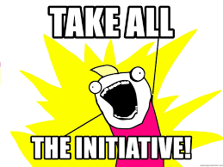

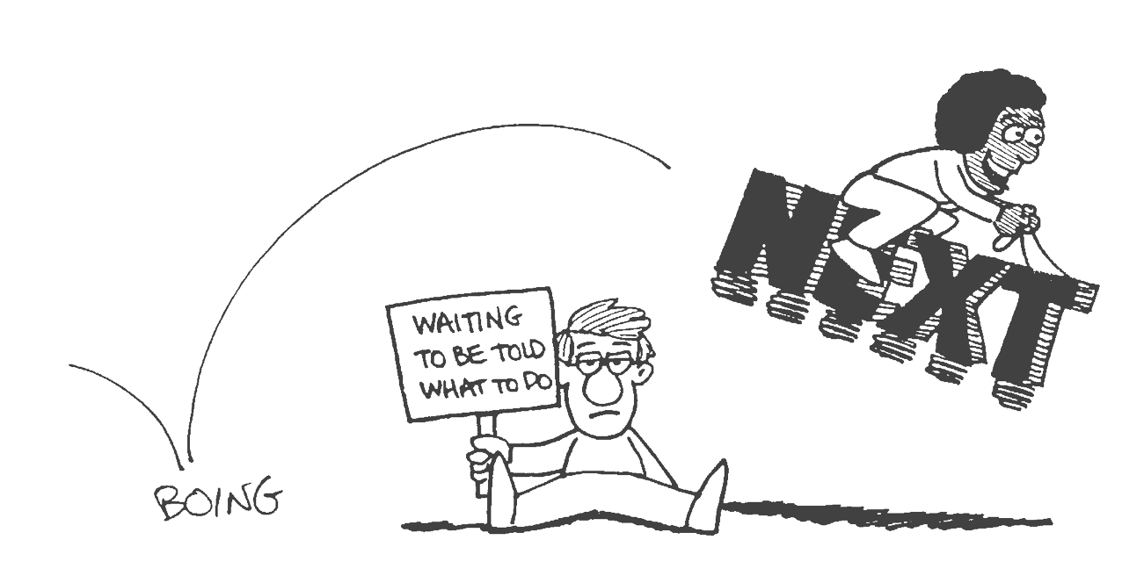

TAKING INITIATIVE: A DESCRIPTION

If you have a job, or an internship, or you are running your own company, there are always tasks that need to be done by you. Doing the tasks that go along with your obligations is one obvious part of taking initiative. In other words, taking initiative is sometimes as simple as just doing your work (or homework, or hobby, etc.). There is more, however.

Sometimes in your work, or life in general, you will see opportunities to change how things are being done, or how you are as a person. If you then also have (or find) an idea about what should change or how to innovate, you can take initiative by taking the time to sit down and work out your ideas. That means setting clear goals and making a ‘step-by-step’ plan on how to get there (and it does not have to be detailed or perfect). It’s possible that others have these ideas as well, but if you are the one who: takes the lead, includes other colleagues in the process, and cooperates; you are the one taking the initiative. Sometimes you will need to get more support from others for your idea. If necessary, that means you will have to convince people to get it.

Finally, taking initiative also is about setting your own (learning) goals at work, school, hobby, and so on. And if you want to make your goals or changes happen at work, for example, that means you will again have to actively communicate with your manager, boss, and other relevant people.

| THE RESULT
Obviously, the results depend on what exactly you are trying to achieve. For S.E.B. we focus on improving your entrepreneurial behaviour at your work, and specifically: introducing change and innovation. The result is then making sure that:

‘your (innovative) idea (for change) is first discussed with relevant others, then worked out in a clear goal and ‘step-by-step’ plan, and finally you should have done additional activities to get more support for the idea’. That’s four things:
- talk
- set goals
- Plan
- get support.

| THE BEHAVIOUR

To give you specific examples of the right behaviour, here’s a list:
- if you don’t know already, learn how to get people behind your idea, initiative or plan. In short: learn how to be convincing.
- That also means that you need to practice on not being easily put off (van de wijs brengen) and that you become persistent (doorzettingsvermogen). Why? Because once you try to convince people of anything, you’ll notice there’s often a level of resistance.
- when there is work that needs to be done you start immediately with enthusiasm and energy. If those two are missing, than just do your best, not every day is a great day.
- When you have an idea, don’t sit on it. Act to get it out in the open. That means that you need to work on getting support for your idea to move forward and that means getting support for your plans.
- In the process of taking initiative always remember this: if you started it, it’s your responsibility to see it through. If it goes wrong that means you take responsibility as well.

| THE COMPETENCES
To summarize, there is a set of skills you might want to learn more about and practice if you want to get better in taking initiative:
- Make decisions
- Act
- convince and influence people
- deal with pressure and setbacks
- showing drive (gedrevendheid) and ambition.

